Jerome Anaeki

**Homework 3**

**Screenshot**

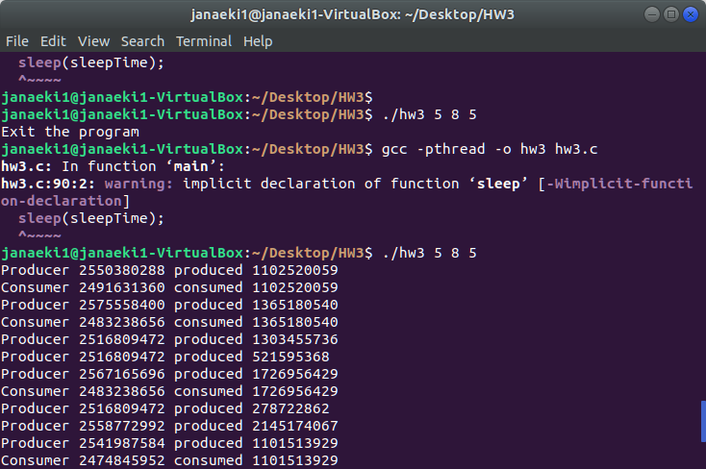

**Code**

#include "buffer.h"

#include <stdio.h>

#include <stdlib.h>

#include <pthread.h>

#include <semaphore.h>

buffer_item buffer[BUFFER_SIZE]; //buffer

int counter; //counter for buffer

sem_t empty, full; //empty and full semaphores

pthread_mutex_t mutex; //mutex lock

pthread_t pid; //ID for producer threads

pthread_t cid; //ID for consumer threads

void *producer(void *param);

void *consumer(void *param);

int insert_item(buffer_item item)

{

if(counter < BUFFER_SIZE) {

buffer[counter] = item; //add item to buffer

counter++; //increment counter

}

return 0;

}

int remove_item(buffer_item *item)

{

if(counter > 0) {

*item = buffer[(counter-1)]; //remove item from buffer

counter--; //decrement counter

}

return 0;

}

int main(int argc, char *argv[])

{

/* Get command line arguments argv[1],argv[2],argv[3] */

int sleepTime, prod, cons;

int i;

if (argc != 4) {

fprintf(stderr,"Usage: ./hw3 <sleep time> <# of producer threads> <# of consumer threads>\n");

return -1;

}

sleepTime = atoi(argv[1]); //user input for sleep time

prod = atoi(argv[2]); //user input for number of producer threads

cons = atoi(argv[3]); //user input for number of consumer threads

if (prod < 2) {

fprintf(stderr,"# of producer threads must be larger than 1\n");

return -1;

}

if (cons < 2) {

fprintf(stderr,"# of consumer threads must be larger than 1\n");

return -1;

}

/* Initialize buffer related synchronization tools */

sem_init(&empty, 0, BUFFER_SIZE); //create empty semaphore

sem_init(&full, 0, 0); //create full semaphore

pthread_mutex_init(&mutex, NULL); //create mutex lock

counter = 0; //initialize counter for buffer

/* Create producer threads based on the command line input */

for(i = 0; i < prod; i++) {

pthread_create(&pid, NULL, producer, NULL);

}

/* Create consumer threads based on the command line input */

for(i = 0; i < cons; i++) {

pthread_create(&cid, NULL, consumer, NULL);

}

/*Join threads*/

for(i = 0; i < prod; i++) {

pthread_join(pid,NULL);

}

for(i = 0; i < cons; i++) {

pthread_join(cid,NULL);

}

/* Sleep for user specified time based on the command line input */

sleep(sleepTime);

return 0;

}

void *producer(void *param)

{

/* producer thread that calls insert_item() */

buffer_item produced_number;

while(1) {

/* sleep for a random period of time */

int random = rand() / 10000000;

sleep(random);

/* generate a random number */

produced_number = rand();

sem_wait(&empty); //acquire empty semaphore

pthread_mutex_lock(&mutex); //acquire mutex lock

if (insert_item(produced_number)){

fprintf(stderr, "report error condition");

}

else{

printf("Producer %u produced %d \n",(unsigned int)pthread_self(), produced_number);

}

pthread_mutex_unlock(&mutex); //release mutex lock

sem_post(&full); //release full semaphore

}

}

void *consumer(void *param)

{

/* consumer thread that calls remove_item() */

buffer_item consumed_number;

while(1) {

/* sleep for a random period of time */

int random = rand() / 10000000;

sleep(random);

sem_wait(&full); //acquire full semaphore

pthread_mutex_lock(&mutex); //acquire mutex lock

if (remove_item(&consumed_number)){

fprintf(stderr, "report error condition");

}

else{

printf("Consumer %u consumed %d \n",(unsigned int)pthread_self(), consumed_number);

}

pthread_mutex_unlock(&mutex); //release mutex lock

sem_post(&empty); //release empty semaphore

}

}